TASK1:

IP ADDRESS: 172.16.11.51 PORT: 64240

TASK2:

IP ADDRESS: 128.119.245.12 PORT: 80

TASK3:

IP ADDRESS: 172.16.11.51 PORT: 64240

TCP BASICS

TASK1:

1. SEQUENCE NUMBER: 0

2. FLAG: 0x002 SYN: SET

TASK2:

1. SEQUENCE NUMBER: 0

2. VALUE OF ACKNOWLEDGMENT FIELD : SET

3. First the segment number, 0x012 is determined. Then the SYN and ACK fields are found to be SET or 1.

4. FLAG: 0x012 (SYN,ACK): SET

TASK3:

SEQUENCE NUMBER: 146009

ANALYZING UDP

TASK1:

NUMBER OF FIELDS: 6 FIELDS: source port, destination port, length, checksum, checksum status, stream index

TASK2:

LENGTH: 58 bytes

TASK3:

The length is the length of the UDP header field.

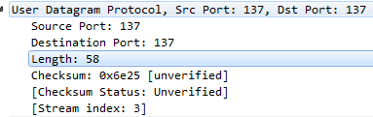

TASK4:

92 bytes

TASK5:

The largest possible source port number is (2^16 – 1) = 65535.

TASK6:

The IP protocol number for UDP is 0x11 hex, which is 17 in decimal value.

ICMP

TASK1:

SOURCE IP: 172.16.11.44

DESTINATION IP: 172.16.11.44

**TASK 2**

The ICMP packet does not have source and destination port numbers because it does not communicate between application layer processes.

TASK 3

Send MSG:

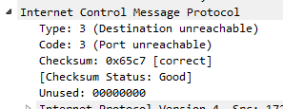

IDENTIFIER FIELDS: 2 bytes

Reply MSG:

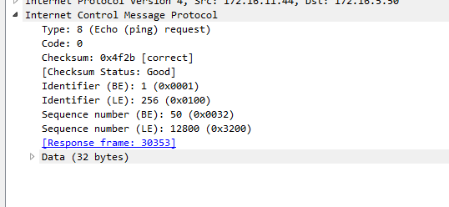

IDENTIFIER FIELDS: 2 bytes